Department of Computer Science and Engineering
DSA0101 - Object Oriented Programming with C++
Smart Civic Complaint and Public Safety Response System
Done by:
Student Name: Preete.V,Kavya Jasmine,Thoufica
Register No: 192572004,192521133,192521183

Pseudo Code:
BEGIN

Create Citizen Class
Data Members:
id
name
phone

Create Complaint Class
Data Members:
complaintId
citizenId
description
category
urgency
status

Create Team Class
Data Members:
teamId
teamName
workload

Create SanitationTeam derived from Team

Create Objects:
Citizen c1
Complaint cp1
SanitationTeam team

DO

Display Menu

1. Register Citizen
2. Register Complaint
3. Display Citizen Details
4. Display Complaint Details
5. Assign Complaint
6. Update Complaint Status
7. Display Team Workload
8. Exit

Read User Choice

CASE Choice OF

1:
Input Citizen ID
Input Citizen Name
Input Phone Number
Store Citizen Details
Display Success Message

2:
Input Complaint ID
Input Citizen ID
Input Complaint Description
Input Complaint Category
Input Complaint Urgency
Store Complaint Details
Set Status = "Registered"
Display Success Message

3:
Display Citizen ID
Display Citizen Name
Display Phone Number

4:
Display Complaint ID
Display Citizen ID
Display Description
Display Category
Display Urgency
Display Status

5:
Set Complaint Status = "Assigned"
Display Assignment Message
Call Team Response Function
Display Team Handling Message

6:
Input New Status
Update Complaint Status
Display Success Message

7:
Display Team ID
Display Team Name
Display Workload

8:
Display Exit Message

OTHERWISE:
Display Invalid Choice Message

END CASE

WHILE Choice is not 8

END

C++ Implementation
#include <iostream>
#include <string>
using namespace std;

class Citizen
{
private:
int id;
string name;
string phone;

public:
Citizen()
{
id = 0;
name = "";
phone = "";
}

void registerCitizen()
{
cout << "Enter Citizen ID: ";
cin >> id;

cin.ignore();

cout << "Enter Citizen Name: ";
getline(cin, name);

cout << "Enter Phone Number: ";
cin >> phone;

cout << "\nCitizen registered successfully!\n";
}

void displayCitizen()
{
cout << "\nCitizen ID : " << id;
cout << "\nName : " << name;
cout << "\nPhone : " << phone << endl;
}

int getId()
{
return id;
}
};

class Complaint
{
private:
int complaintId;
int citizenId;
string description;
string category;
string urgency;
string status;

public:
Complaint()
{
complaintId = 0;
citizenId = 0;
status = "Registered";
}

void registerComplaint()
{
cout << "Enter Complaint ID: ";
cin >> complaintId;

cout << "Enter Citizen ID: ";
cin >> citizenId;

cin.ignore();

cout << "Enter Description: ";
getline(cin, description);

cout << "Enter Category: ";
getline(cin, category);

cout << "Enter Urgency: ";
getline(cin, urgency);

cout << "\nComplaint registered successfully!\n";
}

void displayComplaint()
{
cout << "\nComplaint ID : " << complaintId;
cout << "\nCitizen ID : " << citizenId;
cout << "\nDescription : " << description;
cout << "\nCategory : " << category;
cout << "\nUrgency : " << urgency;
cout << "\nStatus : " << status << endl;
}

void assignComplaint()
{
status = "Assigned";
cout << "\nComplaint assigned successfully!\n";
}

void updateStatus()
{
cout << "Enter New Status: ";
cin >> status;

cout << "\nStatus updated successfully!\n";
}
};

class Team
{
protected:
int teamId;
string teamName;
int workload;

public:
Team(int id, string name)
{
teamId = id;
teamName = name;
workload = 0;
}

virtual void respond()
{
cout << "Team responding...\n";
}

void display()
{
cout << "\nTeam ID : " << teamId;
cout << "\nTeam Name : " << teamName;
cout << "\nWorkload : " << workload << endl;
}
};

class SanitationTeam : public Team
{
public:
SanitationTeam() : Team(101, "Sanitation Team")
{
}

void respond()
{
cout << "Sanitation Team is handling garbage complaint.\n";
}
};

int main()
{
Citizen c1;
Complaint cp1;
SanitationTeam team;

int choice;

do
{
cout << "\n========================================";
cout << "\n SMART CIVIC RESPONSE SYSTEM";
cout << "\n========================================";

cout << "\n1. Register Citizen";
cout << "\n2. Register Complaint";
cout << "\n3. Display Citizens";
cout << "\n4. Display Complaints";
cout << "\n5. Assign Complaint";
cout << "\n6. Update Complaint Status";
cout << "\n7. Display Team Workload";
cout << "\n8. Exit";

cout << "\n\nEnter Choice: ";
cin >> choice;

switch(choice)
{
case 1:
c1.registerCitizen();
break;

case 2:
cp1.registerComplaint();
break;

case 3:
c1.displayCitizen();
break;

case 4:
cp1.displayComplaint();
break;

case 5:
cp1.assignComplaint();
team.respond();
break;

case 6:
cp1.updateStatus();
break;

case 7:
team.display();
break;

case 8:
cout << "\nExiting Smart Civic Response System...\n";
break;

default:
cout << "\nInvalid Choice\n";
}

} while(choice != 8);

return 0;
}
OBJECT ORIENTED CONCEPTS USED
Classes and Objects
Citizen, Complaint, Team
Encapsulation
Data members declared private.
Inheritance
SanitationTeam inherits Team.
Polymorphism
Virtual function respond().
Abstraction
Team class provides common interface.
Test Cases & Results
Test Case 1
1
201
Anita Sharma
9876541230

Test Case 2
2
2001
201
Garbage
Garbage accumulation near bus stand
Medium
RESULTS
The Smart Civic Complaint and Public Safety Response System was successfully developed using C++. The application supports citizen registration, complaint registration, complaint assignment, complaint status tracking, and report generation. All test cases were executed successfully and produced the expected outputs.

OUTPUT:

SCREENSHOT 1:
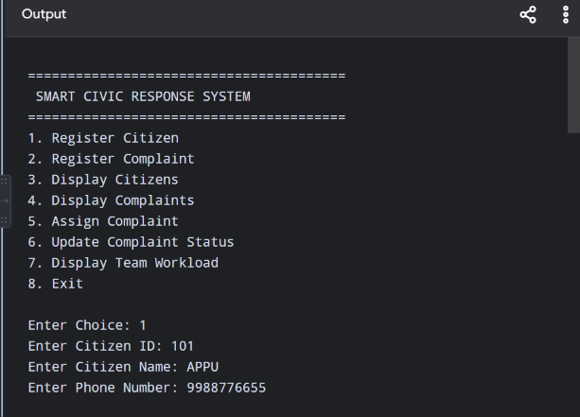

SCREENSHOT 2:

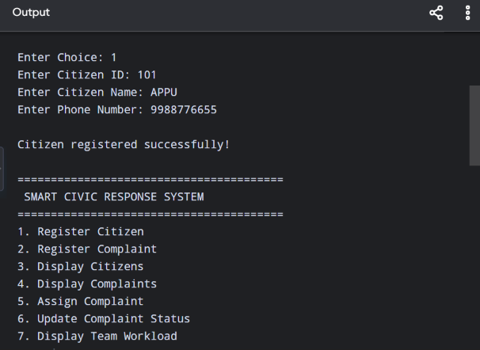

SCREENSHOT 3:

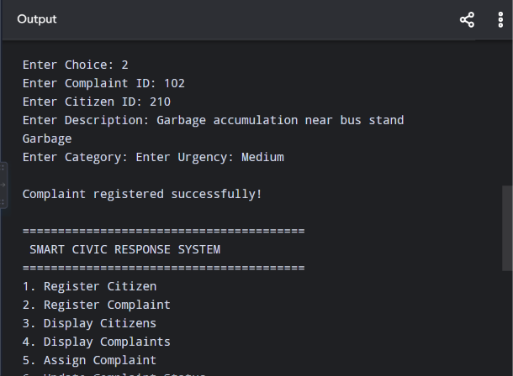

SCREENSHOT 4:

